**Graphing Activities**

*These sheets were adapted from a lab created by Mr. Buckley from Edward Knox High School. Credit is given for this original activity to Mr. Buckley. Available at* [*http://qcpages.qc.cuny.edu/~sfazio100/Graphing%20Activities.doc*](http://qcpages.qc.cuny.edu/~sfazio100/Graphing%20Activities.doc)

**Introduction**

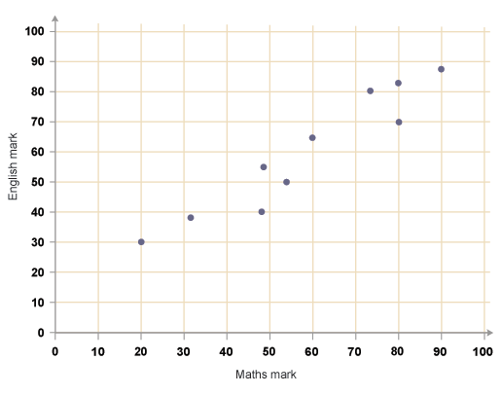It is very important to realise why scientists use graphs to show their data. Most people use graphs to show what the data “looks like” and this generally make data very easy to understand. Bar graphs, column graphs, and pie graphs are very useful for doing this. These sort of graphs are really just a picture of the data and a lot of people like them because they do actually make the data easy to understand. However, generally speaking, scientists don’t use these types of graphs – because scientists expect you to read the data in tables and not need a pie graph or bar graph to see the patterns.

The main type of graph used by scientists is officially called a scatter graph with a trend line, but commonly called a trend line graph. You can easily a scatter graph because the data is shown as a series of dots or crosses. See the example of the right – this is a scatter graph without a trend line.

The scatter graph allows scientists to draw a trend line – a line which represents the pattern shown by the data. The example below is the same graph but with a trend line shown. A trend line is either a straight or a curved line drawn that most accurately describes the trend in the scatter graph. The trend line is very important to scientists. Scientists use the trend line to make predictions and explanations. The trend line is really a mathematical relationship between the variable on the X axis and the variable on the Y axis – and it is this mathematical relationship that scientists determine by drawing and analysing a trend line graph.



A trend line graph must be carefully constructed to accurately depict the data collected.  An incorrect or poorly constructed graph often leads to the acceptance of an incorrect relationship or detract from the acceptance of a correct relationship.  
  
The graph should contain 5 major parts: the title, the independent variable, the dependent variable,   
the scale for each variable, a trend line, and a legend (if there is more than one set of data/line).

1.)   **The title:** this shows what the graph is about.   Reading the title should give the reader  
        an idea about the graph.   It should be a concise statement placed above the graph.

2.)   **The Independent Variable:** this is the variable in the experiment that has been deliberately changed by you (the variable you are investigating). This variable should be placed on the  
horizontal or x-axis.

3.)   **The Dependent Variable**:  this is the variable in the experiment measured by you. It is the result of what happens because of the independent variable is changed. This variable is placed on the y or vertical axis.

4.)   **The Scales for each axis**: The scale is the hardest part of doing a graph. Each step I n the scale should have a consistent amount or increment - multiples of 2, 5, 10, 20, 50 etc. are easy to use while multiples of 1.2, 3, or 15 are harder to use   Your scale must be plotted on the amounof graph space available, and will be dictated by the data points. Trial and error is often used to make a scale.

5.)    **The Legend**:  When more than one set of data is plotted on a graph (that is there is more than one trend line) a legend or Key should tell the reader which data is which.

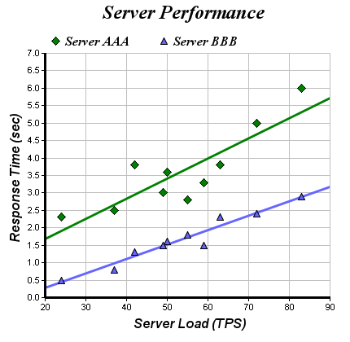6.) T**he Trend Line:** This is a line drawn by you to accurately describe the trend in the data. It must be either a straight line or a smooth curve. It does not have to go through all, or in fact any of the data points – but must be an accurate representation of the trend (pattern) you see in the data points.

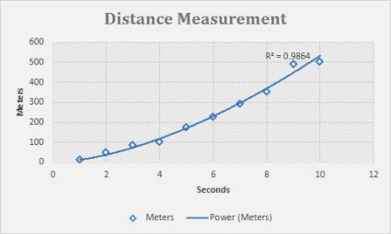**Graphing Activity # 1**

Use the data in the table below to complete the graph provided.  Remember to title your graph and label the axes properly when setting up your scale.

Introduction - When plants are underwater they still photosynthesise using sunlight. This means plants underwater release bubbles of Oxygen gas from their leaves. The relative number of bubbles of oxygen gas released indicates the amount of photosynthesis a plant does and is an indirect guide to the amount of sunlight a plant receives.



Depth (metres)

Bubbles of Oxygen (per min)

Table 1: Water depth and plant photosynthesis

|  |  |
| --- | --- |
| **Depth in meters** | **Number of bubbles/min Plant A** |
| 2 | 45 |
| 5 | 36 |
| 10 | 32 |
| 16 | 29 |
| 25 | 18 |
| 30 | 13 |

Draw a trend line on the graph – Is it straight or curved?

Answer the following questions based on the graph above you just completed.

1. What is the independent variable? ___________________________________________
2. What is the dependent variable?  ____________________________________________
3. What is the Number of bubbles per min you might expect from a plant at:
4. 20 m depth _________
5. 12 m depth _________

**ANALYSIS** (practice at writing an analysis)

1. Write a statement describing a trend you see in the data (one sentence, use the names of the two variables). ________________________________________________________________________ ________________________________________________________________________

Quote some data and explain how it is evidence for your statement above (refer to either the table or the graph) ________________________________________________________________________________________________________________________________________________

Write a statement describing the amount of error you see in the data (one sentence, use the terms very little, insignificant, significant, considerable, excessive). ________________________________________________________________________________________________________________________________________________

Explain why you believe there is this amount of error in the data (choose from these error techniques…does the data make sense? is it close to a correct value? are the points close to the trend line?). ________________________________________________________________________________________________________________________________________________

________________________________________________________________________

**CONCLUSION** (practice writing a conclusion)

1. Write a statement (this is your conclusion) about what this graph or trend tells you (one sentence). ________________________________________________________________________ ________________________________________________________________________

Elaborate or explain the conclusion above (1 or 2 sentences) ________________________________________________________________________________________________________________________________________________

Either explain how your conclusion agrees or disagrees with scientific theory, or use the scientific theory to explain the trend (check the theory statement at the start) ________________________________________________________________________________________________________________________________________________

________________________________________________________________________________________________________________________________________________

Write a statement describing the amount of error you see in the data (one sentence, use the terms very little, insignificant, significant, considerable, excessive). ________________________________________________________________________________________________________________________________________________

Explain how this error may have occurred and make a recommendation to stop this error. ________________________________________________________________________________________________________________________________________________

**Graphing Activity # 2**

Use the data in the table below to complete the graph provided.  Remember to title your  
 graph, label the axes properly when setting up your scale, and make a key.

The history of a tree can be deduced from looking a tree rings. Tree rings are the circular patterns in a trunk cutting. The thicker the tree ring the faster the tree grew during that period of time. A very dark tree ring can mean a bushfire. A very narrow ring means the tree did not grow significantly during that period of time and can indicate poor conditions for growth (eq. drought)



|  |  |  |
| --- | --- | --- |
| **Age of the tree in years** | **Average thickness of the annual rings in cm. Forest A** | **Average thickness of the annual rings in cm. Forest B** |
| **10** | **2.0** | **2.2** |
| **20** | **2.2** | **2.5** |
| **30** | **3.5** | **3.6** |
| **40** | **3.0** | **3.8** |
| **50** | **4.5** | **4.0** |
| **60** | **4.7** | **4.5** |

Draw a trend lines on the graph –straight or curved?

Answer the following questions based on the graph above you just completed.

1. What is the independent variable? ____________________
2. What is the dependent variable?  ____________________________

**ANALYSIS** (practice at writing an analysis)

1. Write a statement describing a trend you see in the data (one sentence, use the names of the two variables. There is more than one trend in the data – pick one). ________________________________________________________________________ ________________________________________________________________________

Quote some data and explain how it is evidence for your statement above (refer to either the table or the graph) ________________________________________________________________________________________________________________________________________________

Write a statement describing the amount of error you see in the data (one sentence, use the terms very little, insignificant, significant, considerable, excessive). ________________________________________________________________________________________________________________________________________________

Explain why you believe there is this amount of error in the data (choose from these error techniques…does the data make sense? is it close to a correct value? are the points close to the trend line?). ________________________________________________________________________________________________________________________________________________

________________________________________________________________________

**CONCLUSION** (practice writing a conclusion)

1. Write a statement (this is your conclusion) about what this graph or trend tells you (one sentence. There is more than one conclusion here, pick one). ________________________________________________________________________ ________________________________________________________________________

Elaborate or explain the conclusion above (1 or 2 sentences) ________________________________________________________________________________________________________________________________________________

Either explain how your conclusion agrees or disagrees with scientific theory, or use the scientific theory to explain the trend (check the theory statement at the start) ________________________________________________________________________________________________________________________________________________

________________________________________________________________________________________________________________________________________________

Write a statement describing the amount of error you see in the data (one sentence, use the terms very little, insignificant, significant, considerable, excessive). ________________________________________________________________________________________________________________________________________________

Explain how this error may have occurred and make a recommendation to stop this error. ________________________________________________________________________________________________________________________________________________

**Graphing Activities Homework**

**Graphing Practice ­ # 3**

|  |  |  |  |
| --- | --- | --- | --- |
| **Concentration of**  **ethylene in ml/L** | **Wine sap**  **Apples:**  **Days to**  **Maturity** | **Golden**  **Apples:**  **Days to**  **Maturity** | **Gala Apples:**  **Days to**  **Maturity** |
| **10** | **14** | **14** | **15** |
| **15** | **12** | **12** | **13** |
| **20** | **11** | **9** | **10** |
| **25** | **10** | **7** | **9** |
| **30** | **8** | **7** | **8** |
| **35** | **8** | **7** | **7** |

Ethylene is a plant hormone that causes fruit to mature. Farmers spray diluted ethylene on their fruit to ripen the fruit.

The data in the table concerns the amount of time it takes for different apples to ripen by spraying a field of trees. The time is from the date of the first application of ethylene.

Make a line graph of the data.

Make a key for the different kinds of apples being graphed.

Draw a trend line for each type of apple?

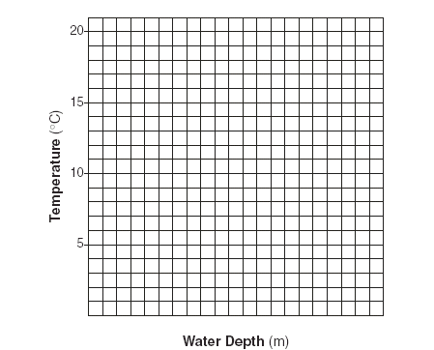What is the dependent variable?

**__________________________________________**

What is the independent variable?

__________________________________________

Describe two trends you can see in the data.

**__________________________________________**

**__________________________________________**

**__________________________________________**

**__________________________________________**

**__________________________________________**

**__________________________________________**

Write two conclusions (one for each of the trends you observed in the data)

**____________________________________________________________________________________**

**____________________________________________________________________________________**

**____________________________________________________________________________________**